Three campaigns:

1. Donate_Test
2. Store_Test
3. Volunteer_Test



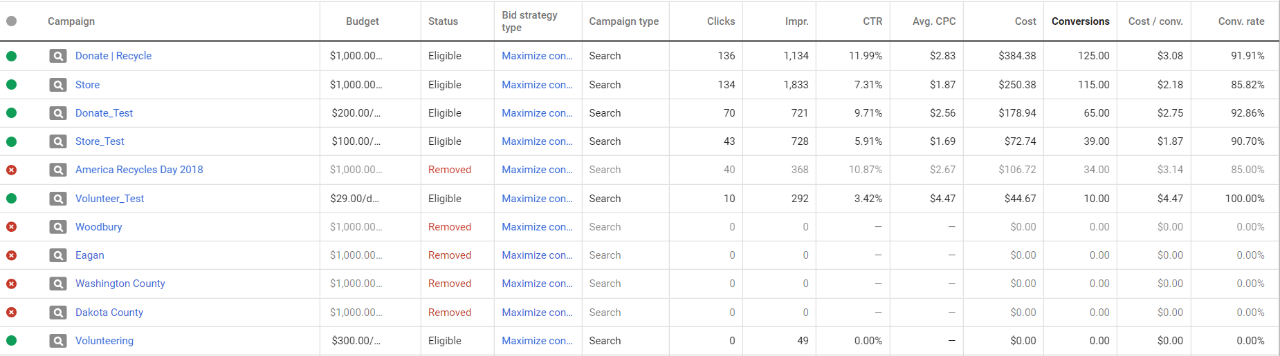

Non-Profit social impact – keeping ewaste off the street and helping needy to sustain in this digitally transforming world by providing training and access to computers/laptops.